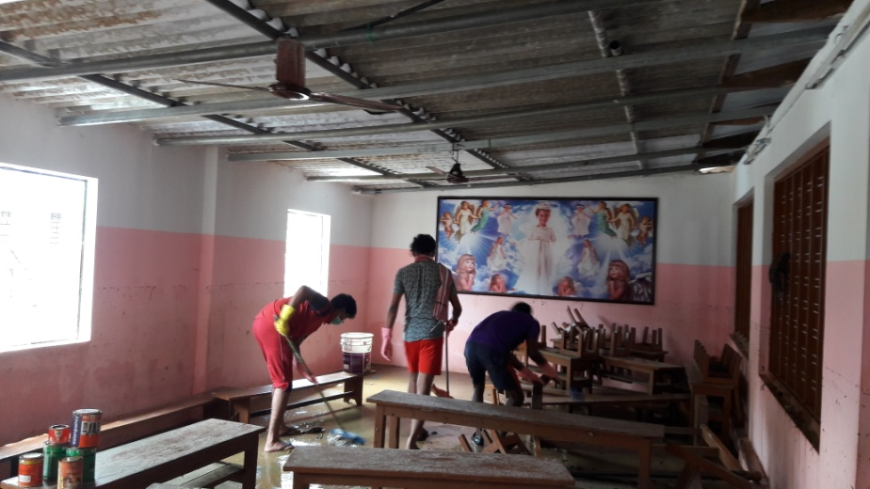

NSS Volunteers Cleaning HF high School, Kainakary, Kuttanad, Alappuzha in the ‘Kuttanad Mega cleaning Drive”, initiated by District Collector, Alappuzha.

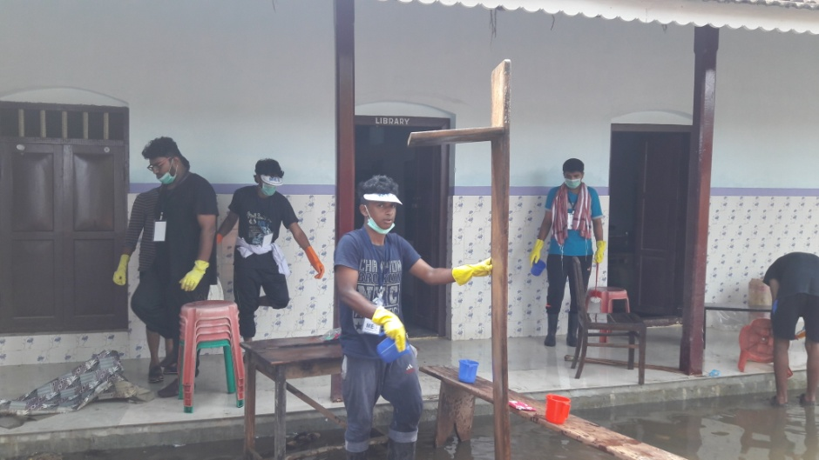

NSS Volunteers Cleaning HF high School, Kainakary, Kuttanad, Alappuzha in the ‘Kuttanad Mega cleaning Drive”, initiated by District Collector, Alappuzha.

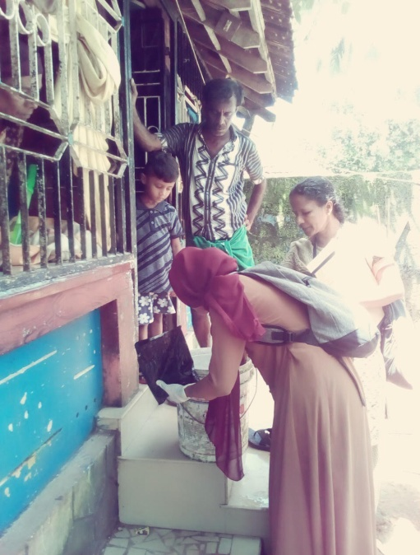 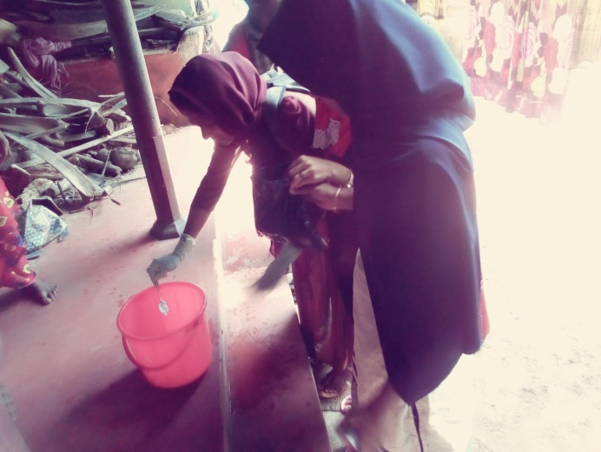

NSS volunteers involving in super chlorination under the aegis of Taluk Hospital , Ponnani.

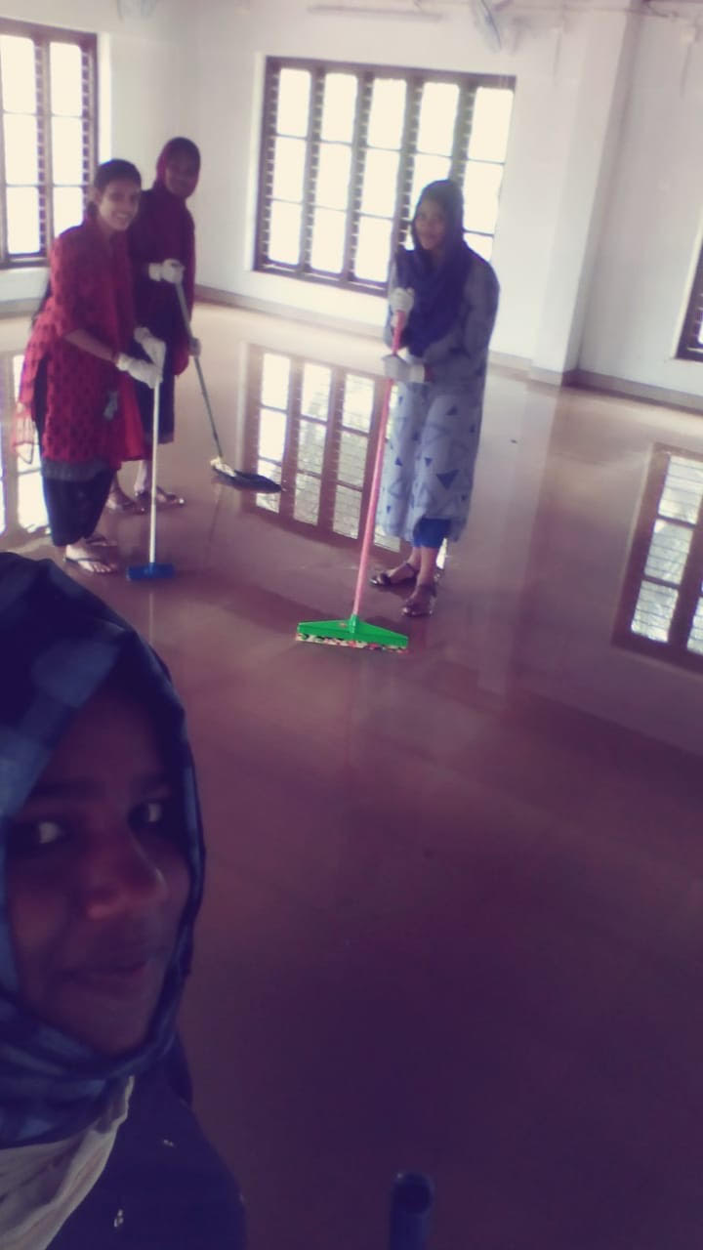

NSS Volunteers cleaning the Coaching Centre for Minority Youths, Ponnani as a part of flood relief mission.

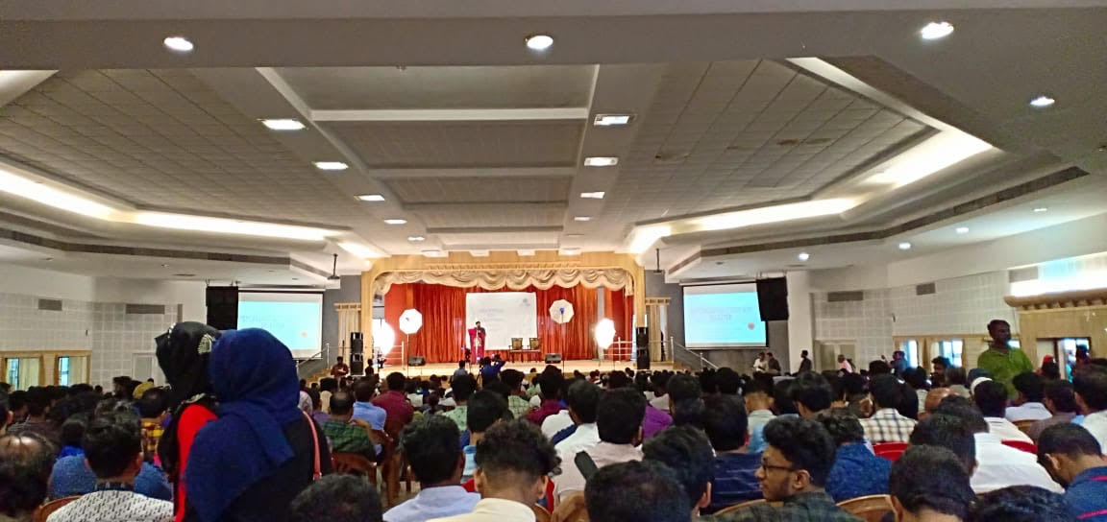

**ANNUAL REPORT ON NSS FOR THE YEAR**

The National Service units of MES Ponnani College has conducted a great number of programmes in the year 2018 -19.The year started with observing world Enviormental day .The volunteers of our College very actively participated in the Post Flood clean mission in the flood affected areas nearby college and many of our volunteers also went to the most water inundated area like Kuttanad , Alappuzha .The volunteers and unit observed all the days and arranged programmes of thought provoking and inspiring.Observed children’s day at Anappady school and conducted various programmes in the school.The special Camp of the units was started on 18 December 2018 , at Goverment Mappila UP school , Veliyankode and initiated and completed much of the pending beautification work of the school and installed a play area for the children of the school .Also arranged a clean drive in the areas like Primary Health centre etc Observed Human rightsday by taking pledge against all the social evils in the society and conducted an awareness class .3 of our volunteers participated in the National camp, Abdul Malik , Athira , Nandakishore .Under  the aegis of Malappuram district police and trauma care units of the district organised self defence programme and training to the girls students of the college a team under the leadership of Asmabi , senior civil police officer conducted the training .As a part of national road safety day volunteers participated in transect walk conducted by Motor vehicle Department .In coalition with Almanar eye hospital, volunteers conducted a survey in adopted village.The volunteers also planted Jack fruit saplings in campus.The volunteers of the two NSS units regularly checking the cleanliness of the college by keeping it Eco friendly and plastic free campus .the units also collected a sum of money on palliative day and distributed to the needy ..The volunteers also visited the dialysis centre of Ponani taluk hospital on world kidney day and spent a day with them.

NSS volunteers actively involved in the cleaning of College campus as part Swachh Bharath Pakwada on 10th Aug, 2018.

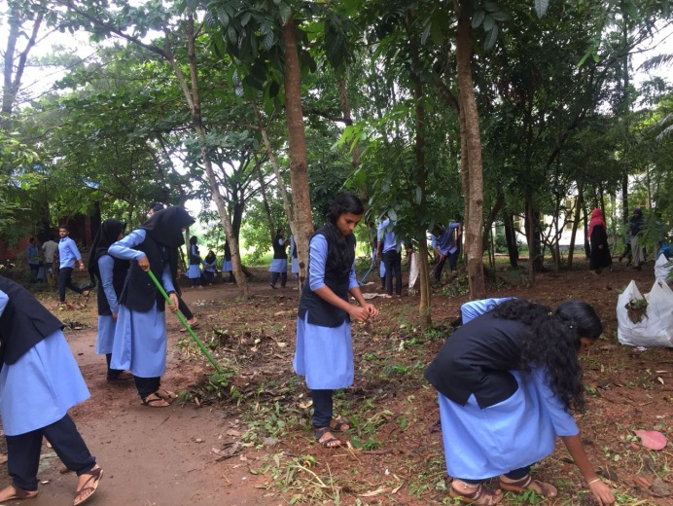 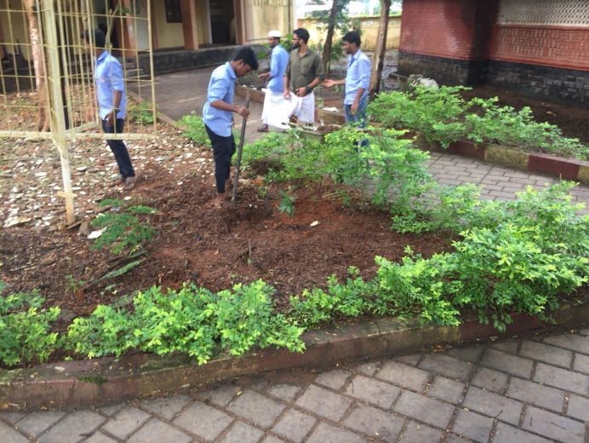

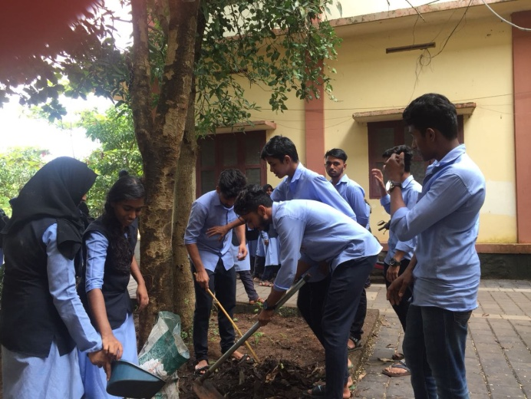 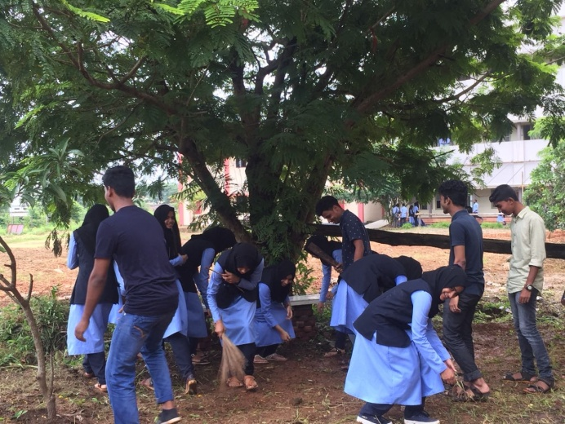



NSS Volunteers cleaning the Coaching Centre for Minority Youths, Ponnan

|  |  |
| --- | --- |
| jack 3 | jack 1 |
| j6 | j7 |

**Detailed Day Wise Report on Special Camp 2018-19**

The National Service Scheme special camp of the academic year 2018-19 commenced on 22 December 2018 at GMUP SCHOOL Veliancode South .The camp was inaugurated by Veliyancode Grama Panchayath President Smt. Suhara Kadayil in the presence of the college Principal Capt. Mohamed Koya and the ward members of the Panchyath and Head Master, PTA members, and Managing Committee of the School. Of the seven days in the camp the volunteers have been benefitted with informative, persuasive and entertaining sessions. The classes were taken by skilled personalities on the topics like Leadership in action, group dynamics, Health and youth, Personality Development, Agriculture and Youth etc.Our proposed project was at the same school of camping and the Primary Health centre Veliyancode. In the school the work undertake by the volunteers were repair Works, Such as welding of equipments of Play Park for children, cementing and concreting of the unfinished and damaged area of the school and Painting and Art works in the children’s park and Gardening in the school at G.M. U.P. School, Veliancode and also various other parts of the Government Mappila School, Veliancode. We end up in recreating the school in much more Beauty than witnessed before and in the Primary Health Centre, veliyancode initiated and volunteered in completing the Cleaning, beautification and planting of Mango saplings and installation of a vegetable garden .The mission was successfully completed and the news being telecasted by the local news channel. The camp ended on 28 December, the valedictory ceremony presided by the Abdul Nafih, P.K., Riyas pazhanji, Member, Veliancode Panchayath inaugurated the session and Abdul Khader, Head Master, GMUP School was the chief guest of the function.

Day 1 (22-12-2018) Saturday

Inauguration ceremony started at 10.am, the camp was inaugurated by Veliyancode Grama Panchayath President Smt. Suhara Kadayil in the presence of the college Principal Capt. Mohamed Koya and the ward members of the Panchyath and Head Master, PTA members, and Managing Committee of the School. The first work the volunteers took in action was cleaning and ensuring the sanitary facilities and toilets in the school and the classrooms in the school. After the lunch break, an ice break session was handled by Farisha, V.M. to get know each other and to start the social living. In the evening, an informative cum entertaining session being handled by Dr. K.M. Jayasree, Assistant Professor of Malayalam on the topic “ Nammude Ponnani”.

|  |  |
| --- | --- |
| C:\Users\User\Desktop\NSS\photos sp camp 2018\ca7ee4cd-03e4-469d-a107-7f3cf8304a55.jpg | C:\Users\User\Desktop\NSS\photos sp camp 2018\IMG-6148.jpg |

Day II (23-12-2018) Sunday

The Second day started with morning yoga practices to the students. The Morning assembly as per schedule started 8.00 AM, hoisted the NSS Flag, and released the camp news paper by the assigned group of volunteers. After the breakfast the volunteers being diverted to primary health centre, veliancode, worksite in different groups. Volunteers cleaned entire surrounding of health centre and segregated medical waste, plastic material for proper green disposal.

To integrate the volunteers’ working together in team enhancement, a team building and leadership session was arranged and the session was handled by Sri. Rifa Shalees, Trainer, Olive Ridley.

In the evening the camp was rejuvenated with programmes like debates and cultural programmes. The second day ended with camp review of the day.

|  |  |
| --- | --- |
| C:\Users\User\Desktop\NSS\photos sp camp 2018\1f0db96f-8799-415d-8a58-1b9754521eb3.jpg | C:\Users\User\Desktop\NSS\photos sp camp 2018\90e450c2-3ed6-4d82-8b85-cdbdff0f1be9.jpg |

Day III (24-12-2018) Monday

The Third day started with morning yoga practices to the students. The Morning assembly as per schedule started 8.00 AM, hoisted the NSS Flag, and released the camp news paper by the assigned group of volunteers. After the breakfast the volunteers being diverted to primary health centre, veliancode, worksite in different groups. Volunteers completed the Cleaning, beautification and planting of Mango saplings in the Primary Health Centre, Veliancode.

To build social commitment and awareness towards the nature and society, persuasive session arranged, that was leaded by Prof. Sankaranarayanan, former professor, IIT, Bombay on the topic “My waste, My responsibility”. In which he articulated the importance of proper waste management and citing the “Green Protocol”.

In the evening the camp was stimulated with various programmes like discussions and cultural programmes. The Third day ended with camp review of the day.

|  |  |
| --- | --- |
| C:\Users\User\Desktop\NSS\photos sp camp 2018\fc52b7e6-735d-4b90-83dc-ecb788dbc9fa.jpg | C:\Users\User\Desktop\NSS\photos sp camp 2018\7ec29251-3e1f-47a8-8231-fd7fd41c67fa.jpg |

Day IV (25-12-2018) Tuesday

The Forth day started with morning yoga practices to the students. The Morning assembly as per schedule started 8.00 AM, hoisted the NSS Flag, and released the camp news paper by the assigned group of volunteers. The main activity of the day is repair Work, such as welding of equipments of play park for children, cementing and concreting of the unfinished and damaged area in the school at G.M. U.P. School, Veliancode. Cleaned and chlorinated the unused well in the school and refined it utilizable.

To build social commitment and awareness towards the environment, informative session arranged, that was guided by Dr. V.K. Brijesh. Assistant professor, of geology on the topic “Man and environment”.

In the evening the camp was stimulated with various programmes like discussions and cultural programmes. The Forth day ended with camp review of the day.

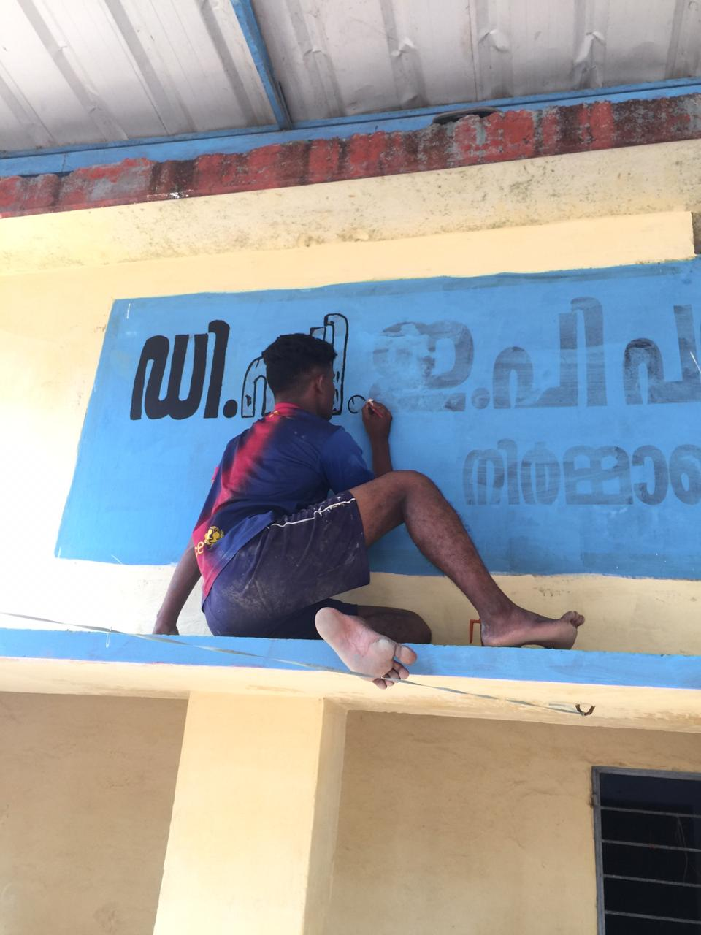

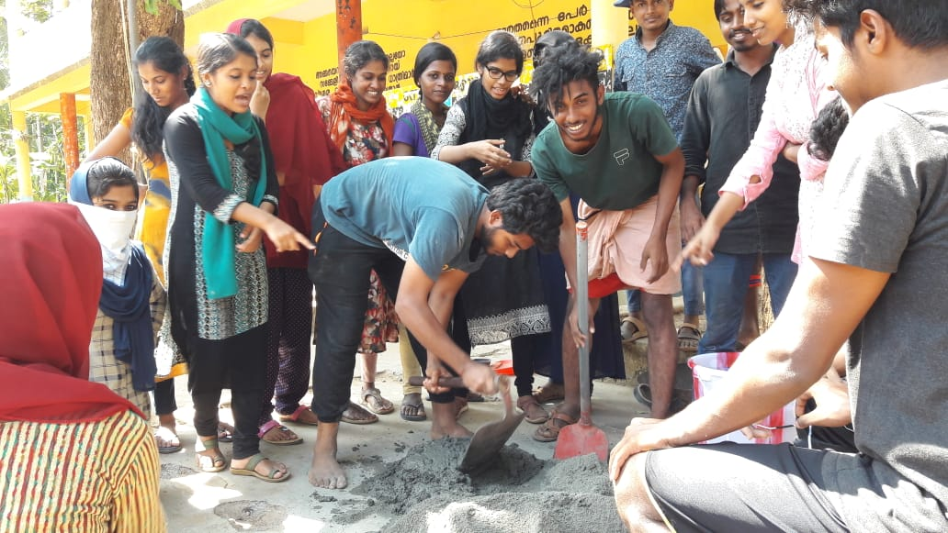

Day V (26-12-2018) Wednesday

The day started with morning yoga practices to the students. The Morning assembly as per schedule started 8.00 AM, hoisted the NSS Flag, and released the camp news paper by the assigned group of volunteers. In this day volunteers have continued with the previous day’s work and mainly focused on painting children’s park area, main stage and various parts of the school.

A practical session on “ How to build an aquarium and its maintenance” conducted by Sri. Sai Krishna. In the evening the camp was filled with various programmes like discussions and cultural programmes. The Fifth day ended with camp review of the day.

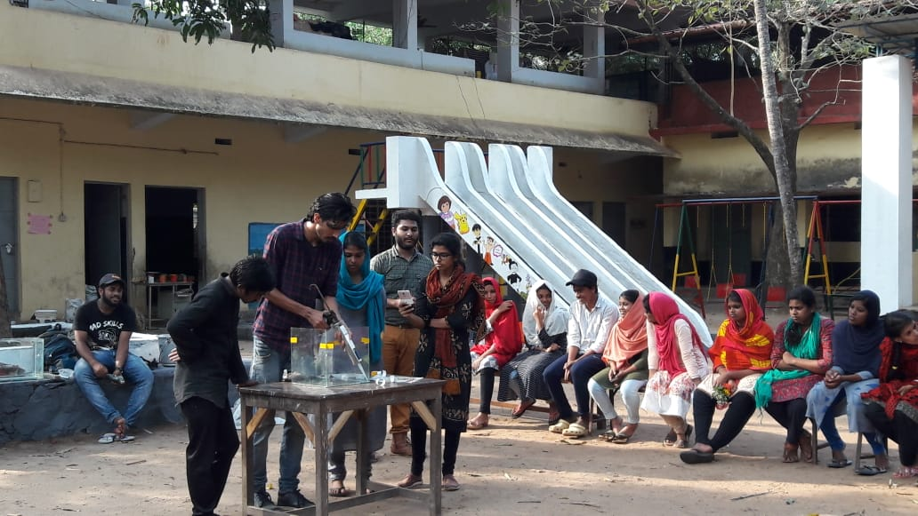

Sri. Sai Krishna handling a session on “How to build an aquarium and its maintenance”.

Day VI (27-12-2018) Thursday

The day started with morning yoga practices to the students. The Morning assembly as per schedule started 8.00 AM, hoisted the NSS Flag, and released the camp news paper by the assigned group of volunteers. In this day volunteers have continued with the previous day’s work and mainly focused on painting children’s park area, main stage, Art works in the children’s park and various other parts of the Government School.

An Interesting session on “lifestyle Education” handled by Sri. Abdul Ali Pasha, Trainer, European Study Centre, Calicut. In the evening the camp was filled with various programmes like discussions and cultural programmes. The Sixth day ended with camp review of the day.

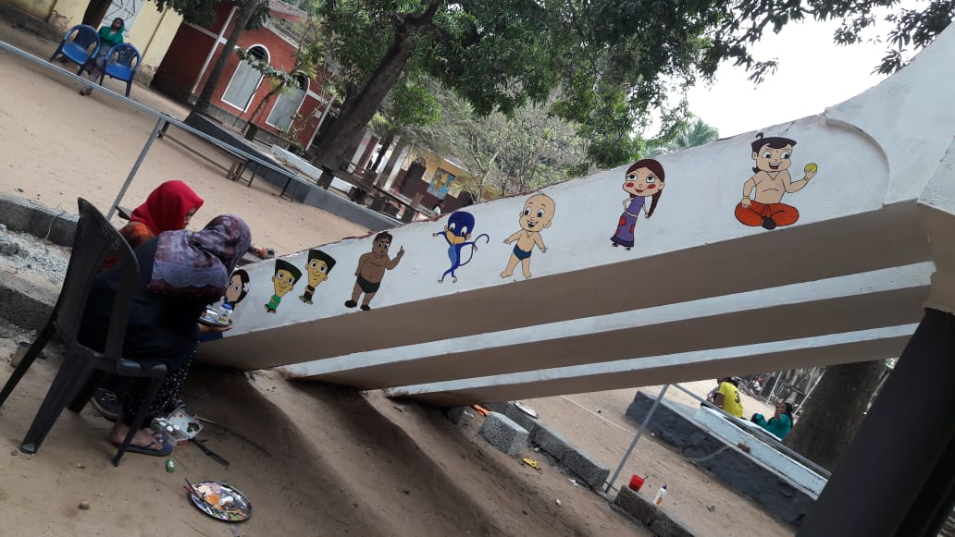

Volunteers engaged in the artwork at the children’s play area.

Day VII (27-12-2018) Thursday

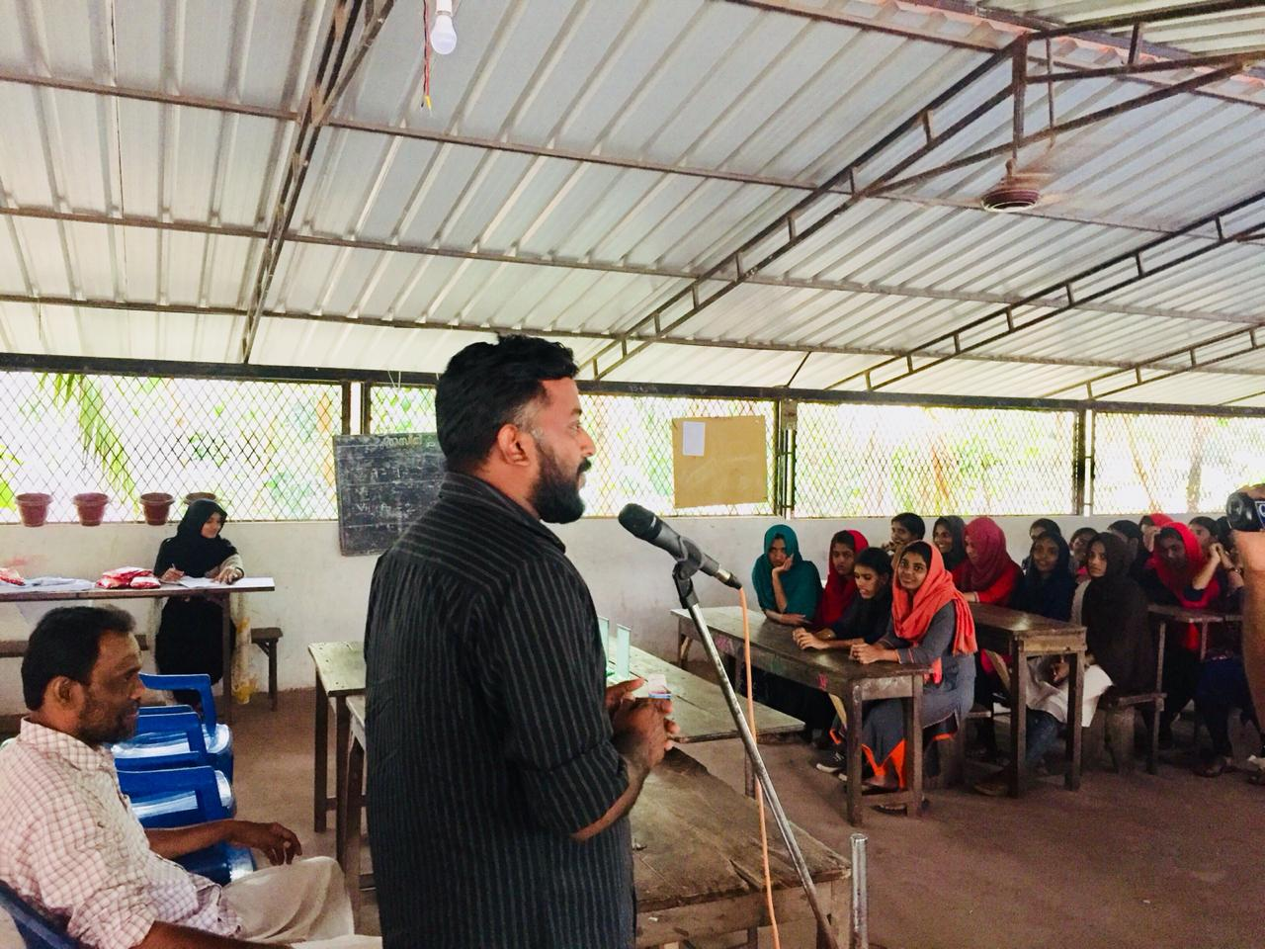

Sri. Riyas Pazhanji addressing the volunteers in the valedictory

The day started with morning yoga practices to the students. The Morning assembly as per schedule started 8.00 AM, hoisted the NSS Flag, and released the camp news paper by the assigned group of volunteers. On the concluding day of the special camp volunteers cleaned the school surroundings, the class rooms and, and they packed their luggage to leave from the camp. In the feedback session they shared their experiences and articulated their view on being in the camp.

valedictory ceremony presided by the Abdul Nafih, P.K., Riyas pazhanji, Member, Veliancode Panchayath inaugurated the session and Abdul Khader, Head Master, GMUP School was the chief guest of the function.